**STUDENT HANDOUT CSS-CHAPTER1**

**CSS INTRODUCTION**

**About Workshop:**

In this workshop, we'll cover everything from the basics of CSS to styling a web application's structure created by HTML tags. This chapter is divided into five workshops, each of which illustrates how to effectively use style properties, how to insert a stylesheet into an HTML document, and how to select selectors from HTML elements in your application.

The Scrum Master can divide the workshop among team members, and you can proceed to walk through the tasks assigned to you.

**WORKSHOP1:**

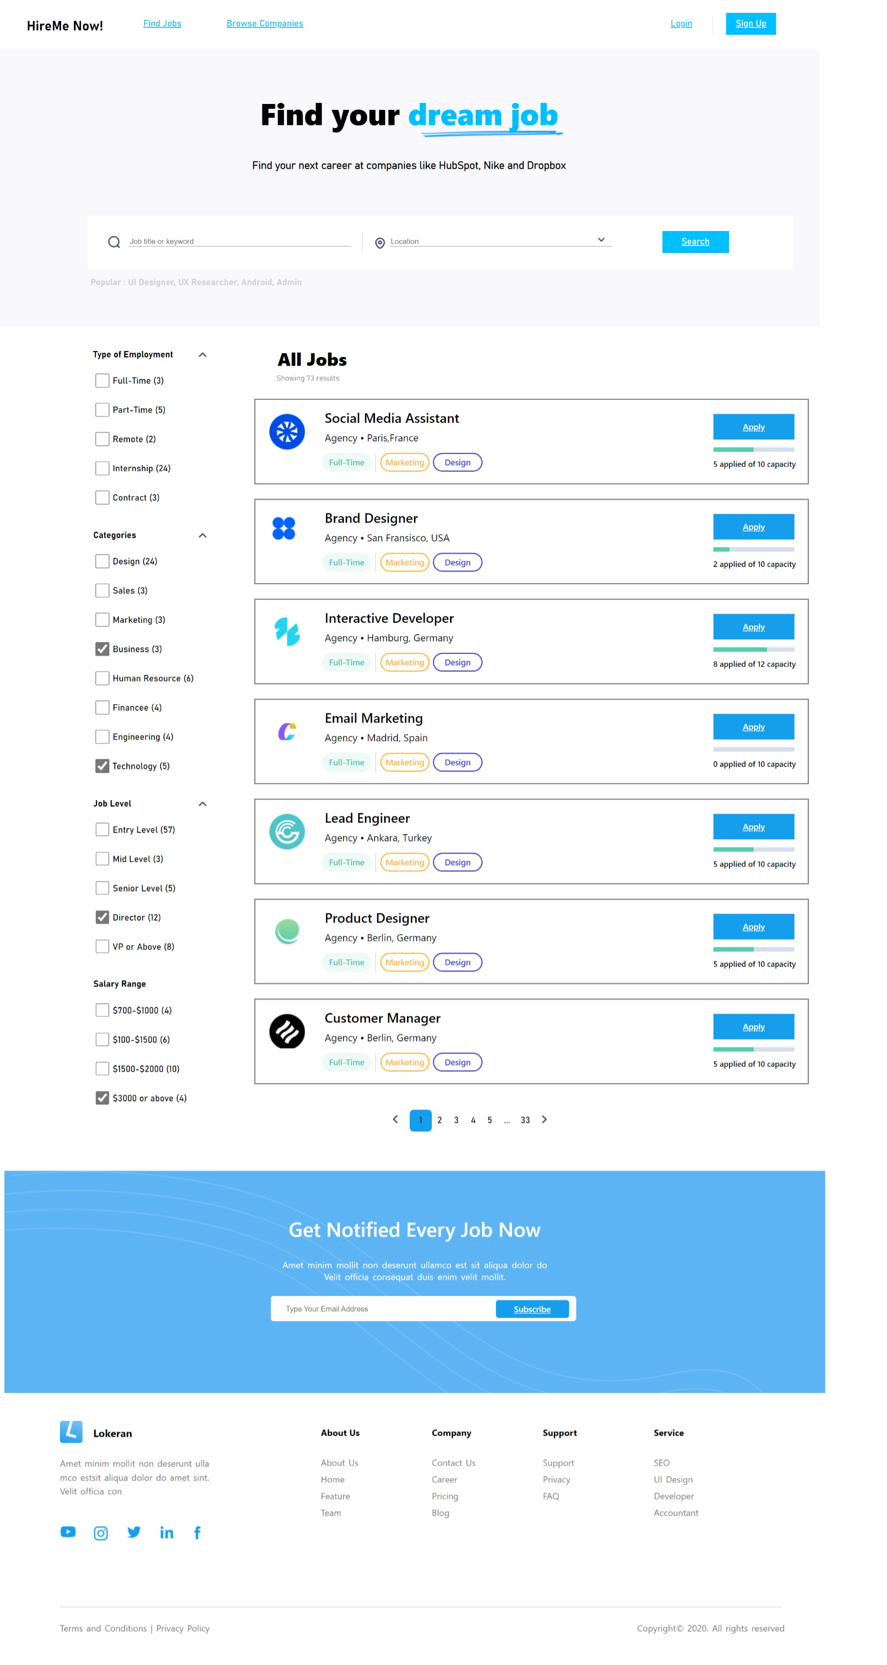

**Expected output:-**



During this workshop, we will construct a webpage for the Job Portal System using HTML tags and style it using CSS. We will include both internal and inline CSS to demonstrate how CSS is applied. In this workshop, we will focus on how to select selectors and use typography properties, font properties, and background properties in CSS. Additionally, students will be assigned additional tasks to add a footer to the template using HTML tags and CSS to achieve the expected output.

**WORKSHOP2:**

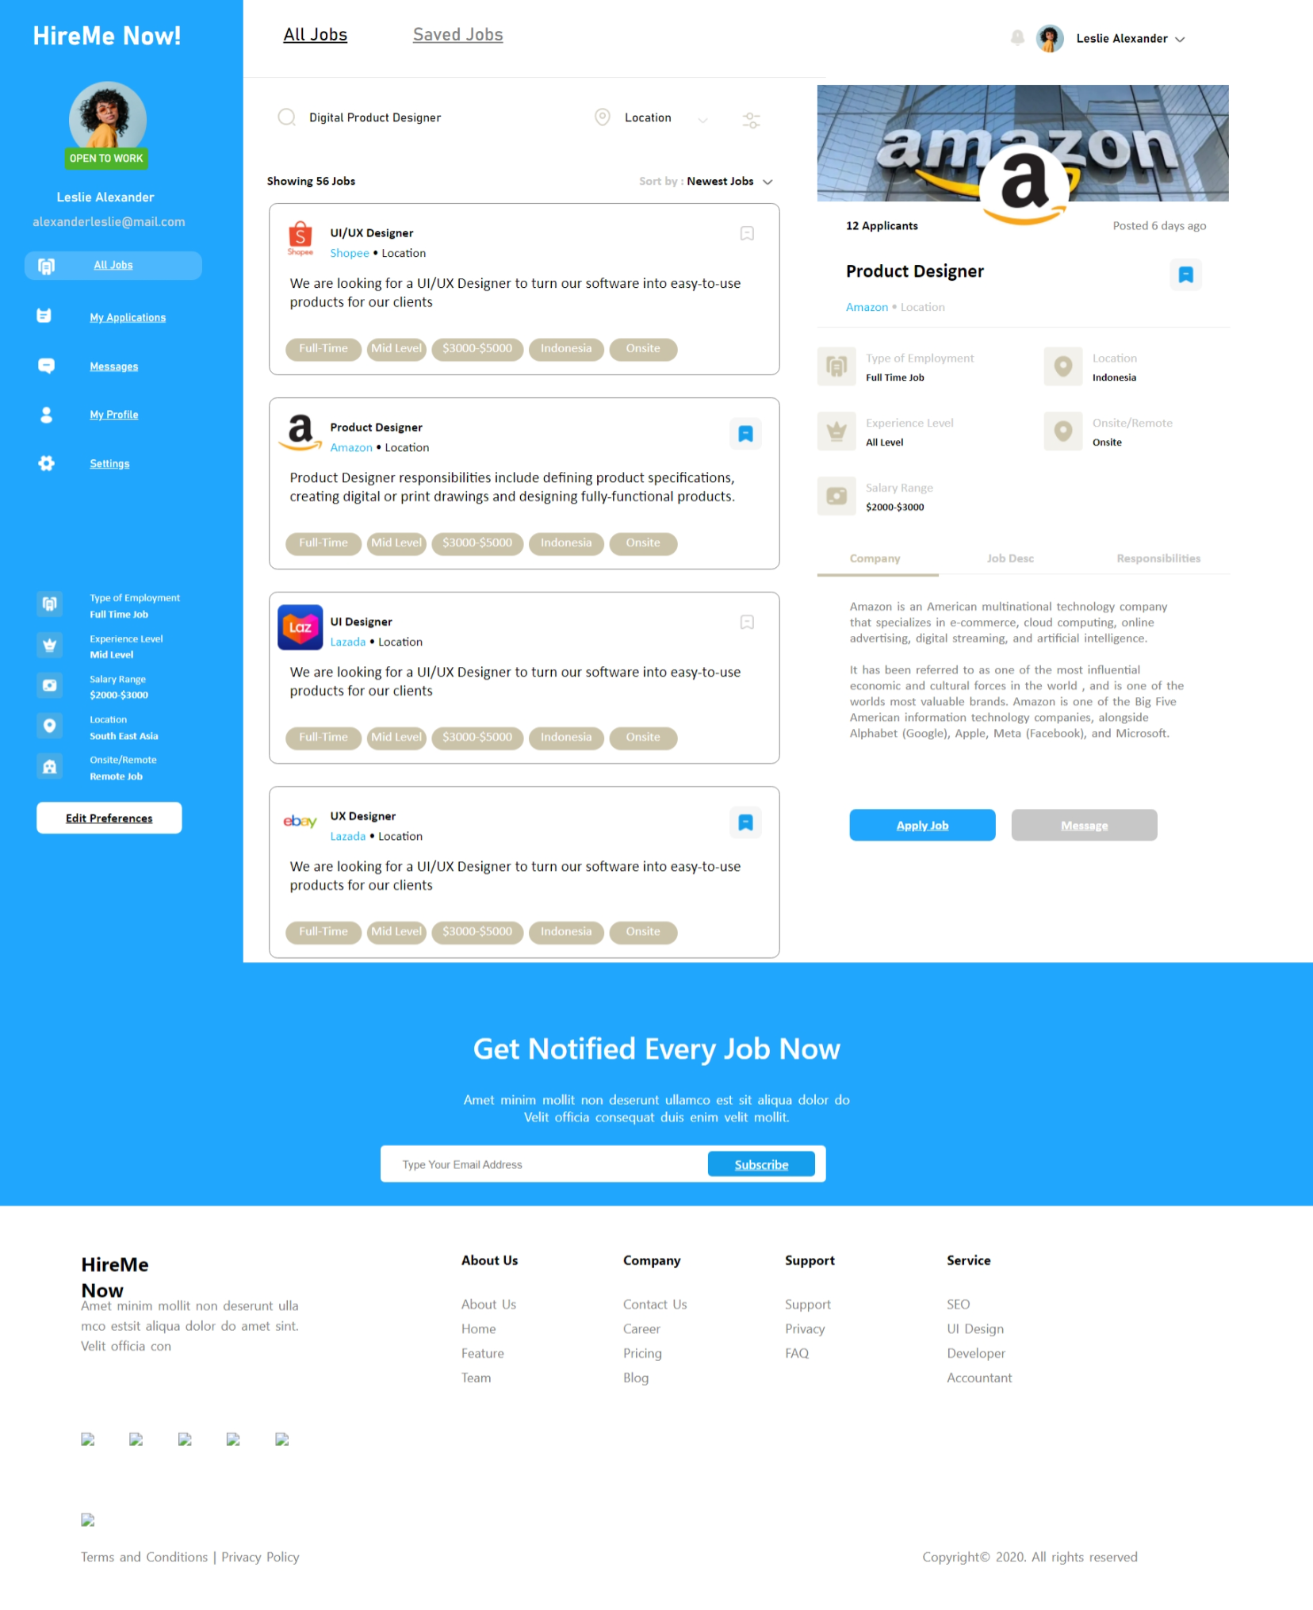

**Expected output:-**

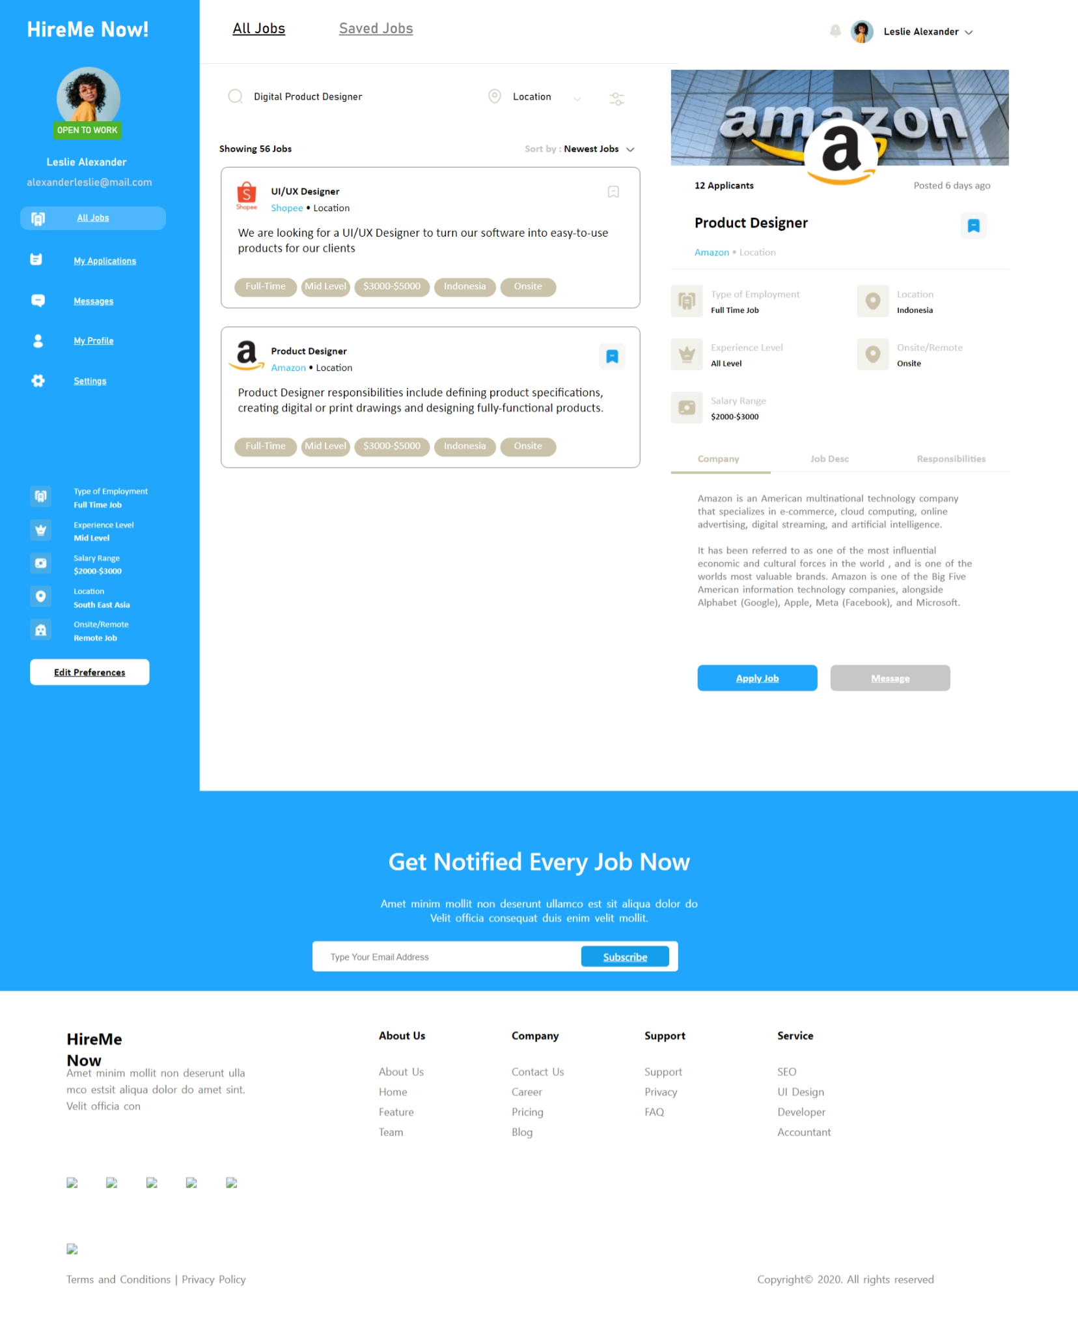

During this workshop, we will construct a webpage for the Job Portal System using HTML tags and style it using CSS. We will include both internal, inline, and external CSS to demonstrate how CSS is applied. In this workshop, we will focus on how to select selectors and use typography properties, font properties, and background properties in CSS. Additionally, students will be assigned additional tasks to add two job lists to the template using HTML tags and CSS to achieve the expected output.

**WORKSHOP3:**

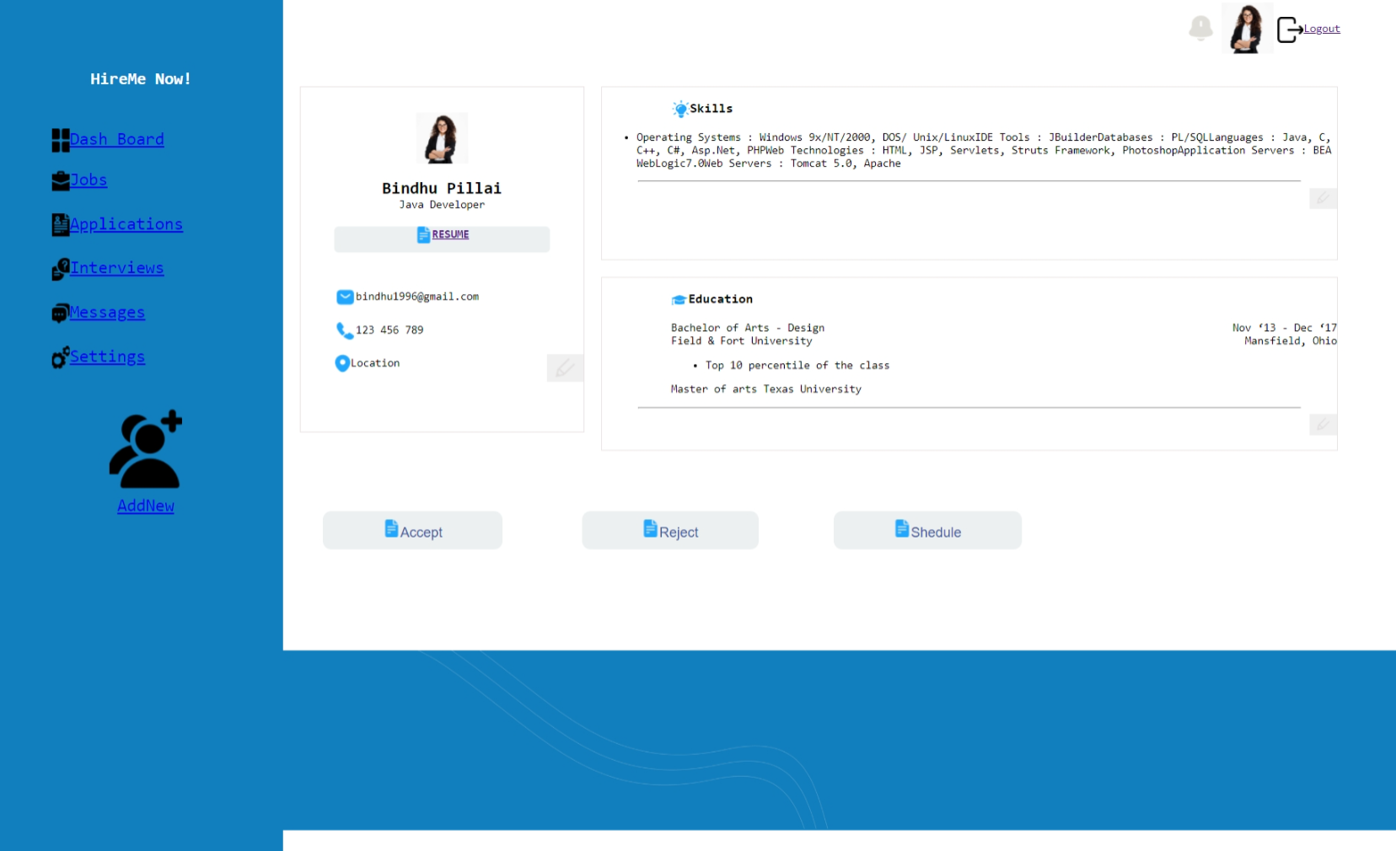

**Expected Output:**

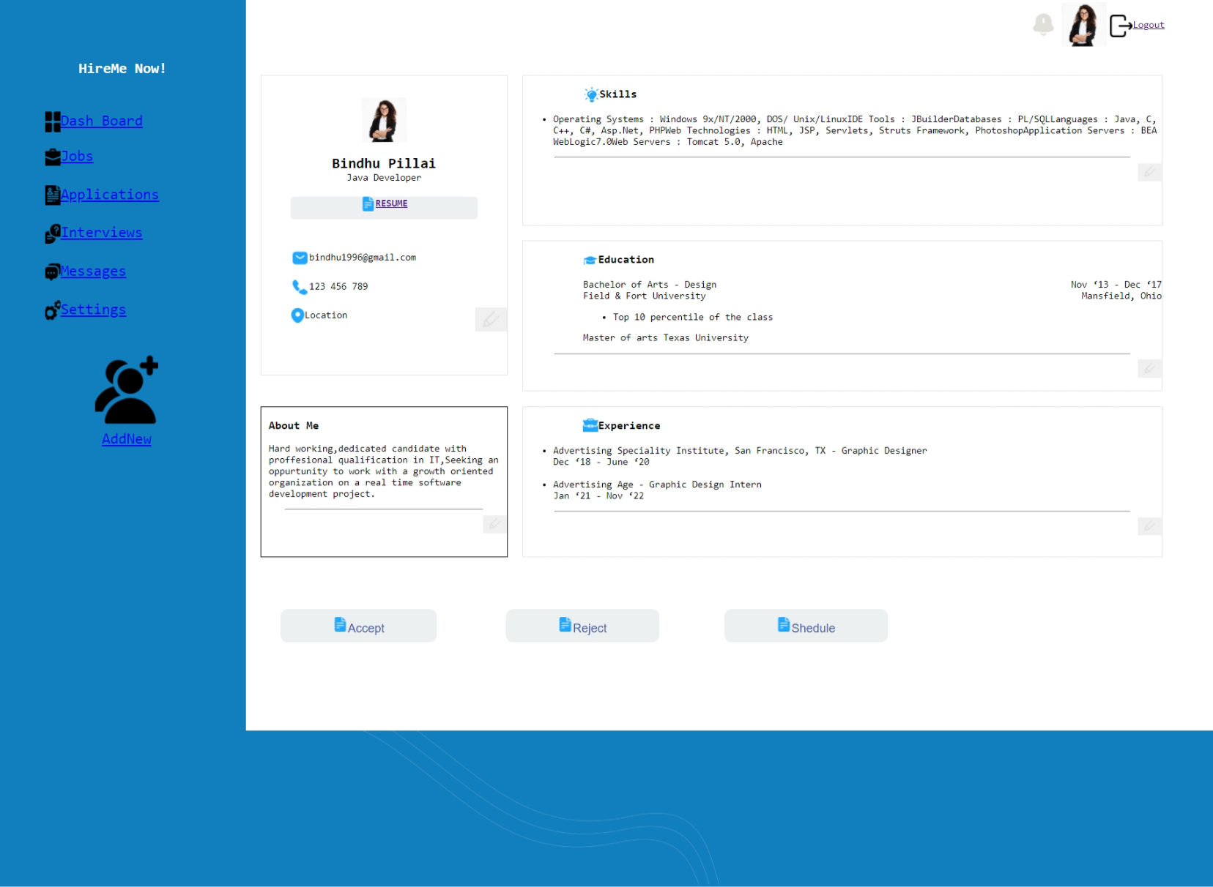

During this workshop, we will construct a webpage for the Job Portal System using HTML tags and style it using CSS. We will include both internal, inline, and external CSS to demonstrate how CSS is applied. In this workshop, our primary focus will be on selecting selectors and utilizing typography properties, font properties, and background properties in CSS. Additionally, students will be assigned additional tasks to add two blocks, "About Me" and "Experience," to the template using HTML tags and CSS to achieve the expected output.

**WORKSHOP4:**

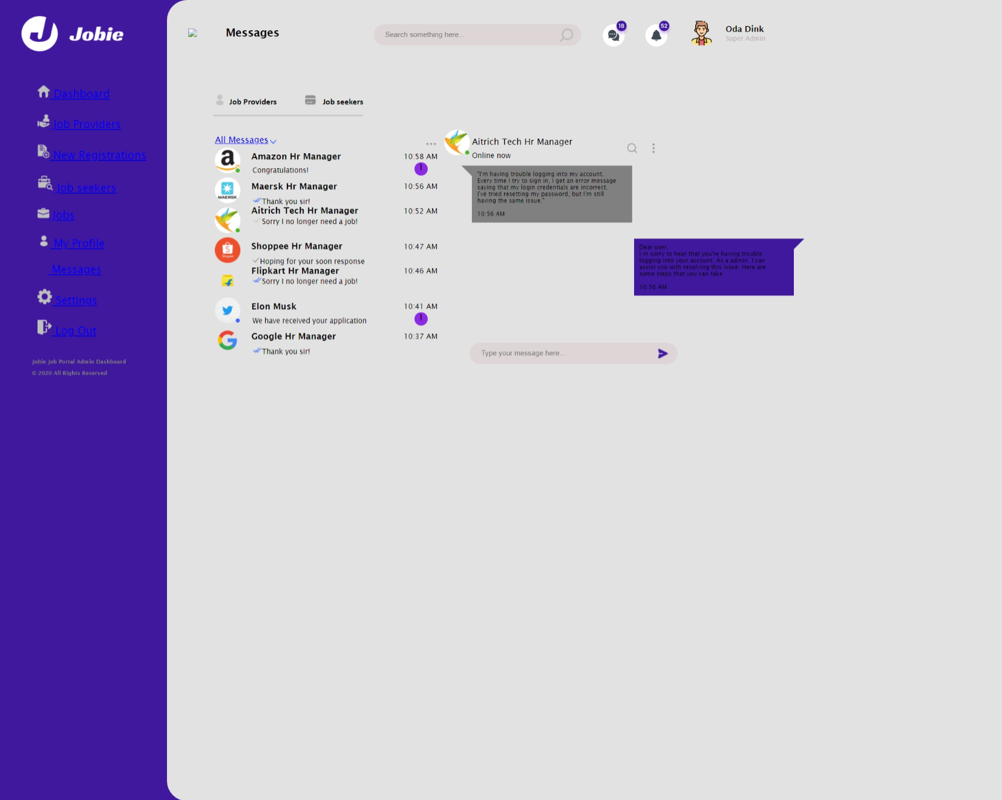

**Expected Output:**

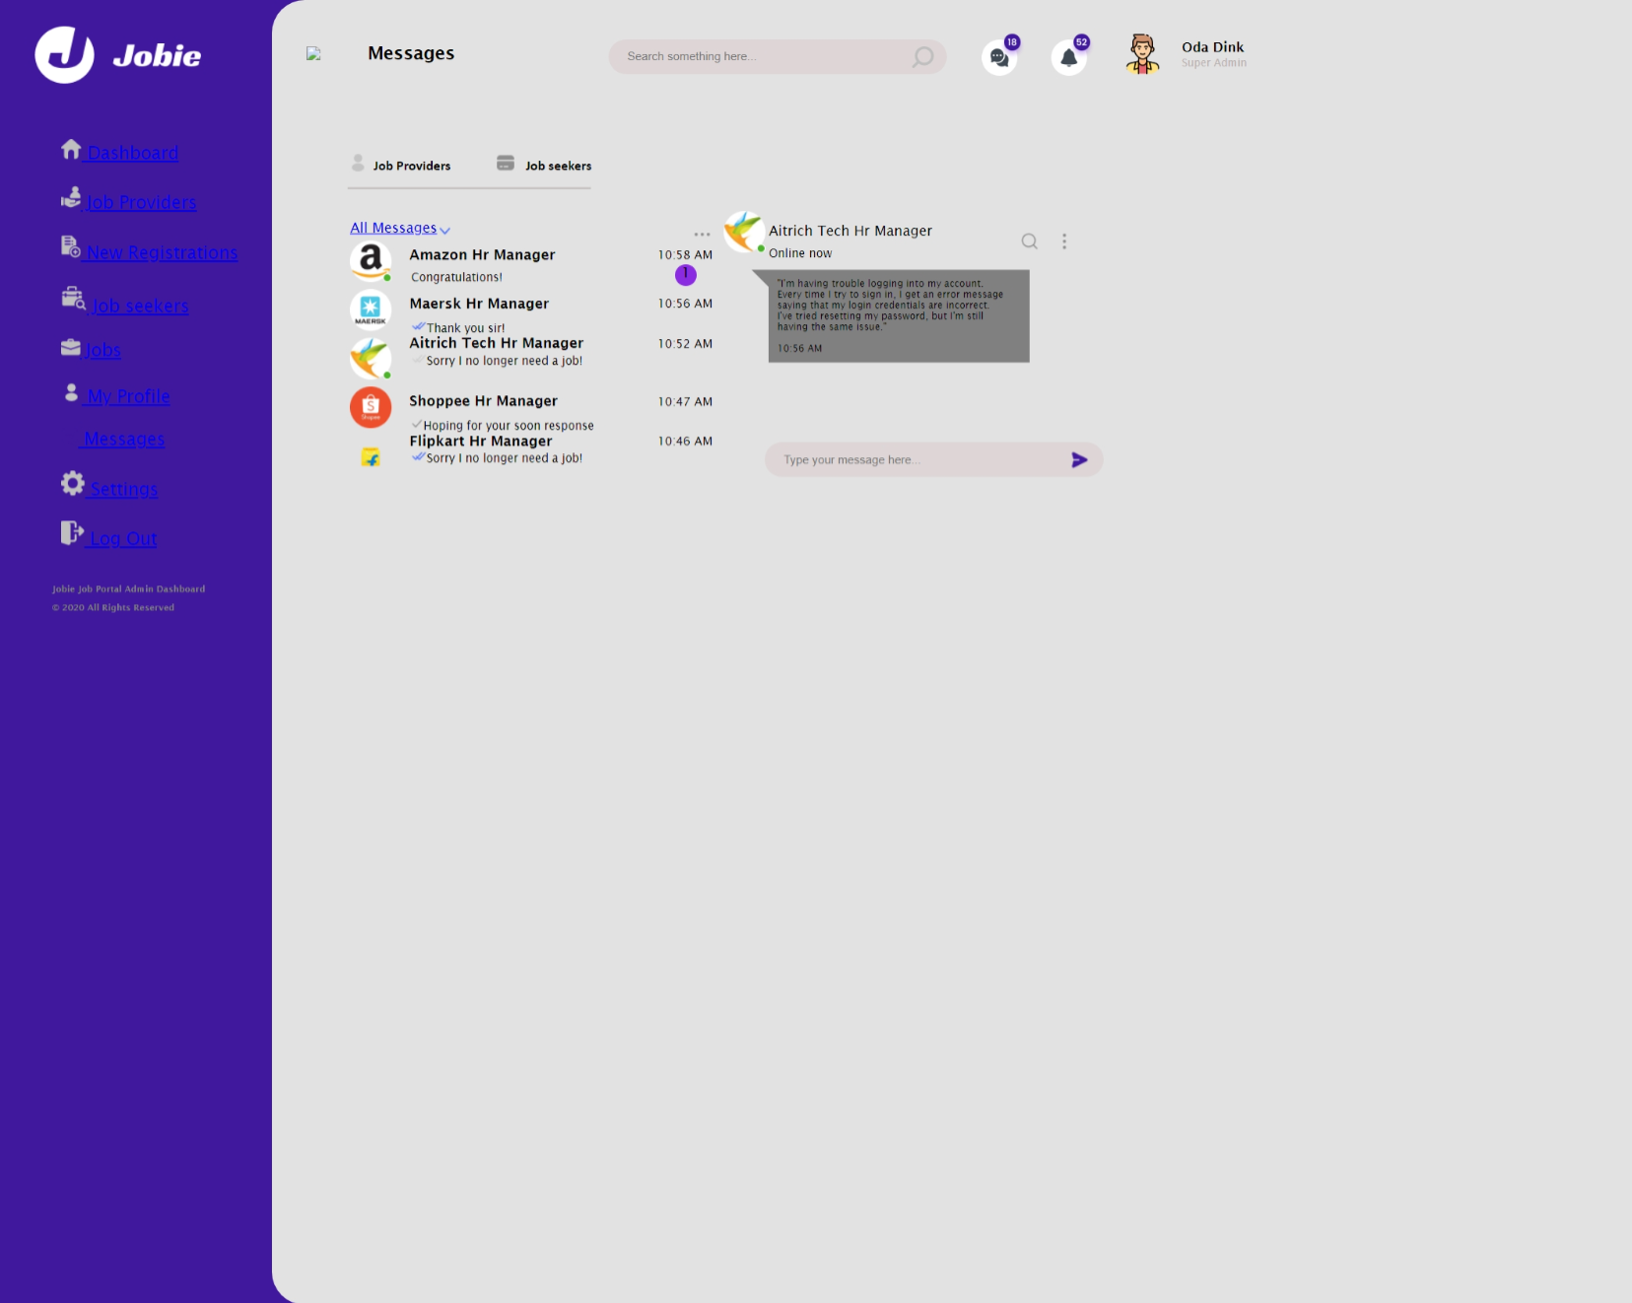

During this workshop, we will construct a webpage for the Job Portal System using HTML tags and style it using CSS. We will include both internal, inline, and external CSS to demonstrate how CSS is applied. In this workshop, our primary focus will be on selecting selectors and utilizing typography properties, font properties, and background properties in CSS. Additionally, students will be assigned additional tasks to add two messages and a message box to the template using HTML tags and CSS to achieve the expected output.

**WORKSHOP5:**

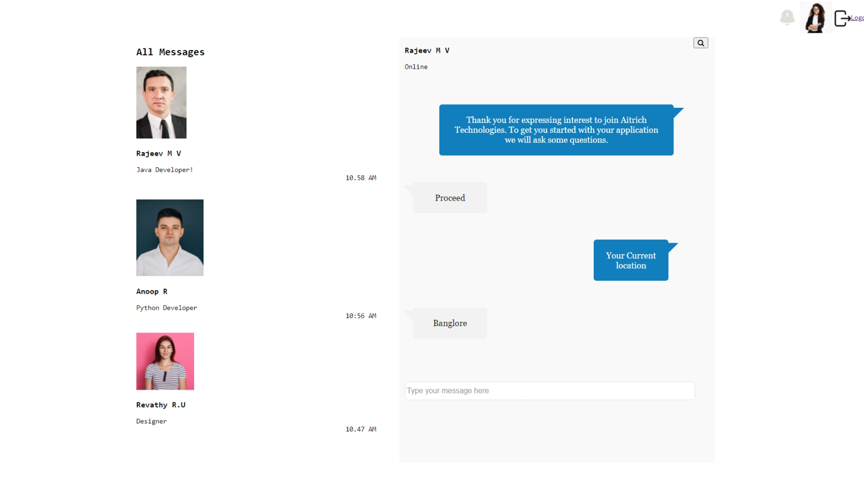

**Expected output:-**

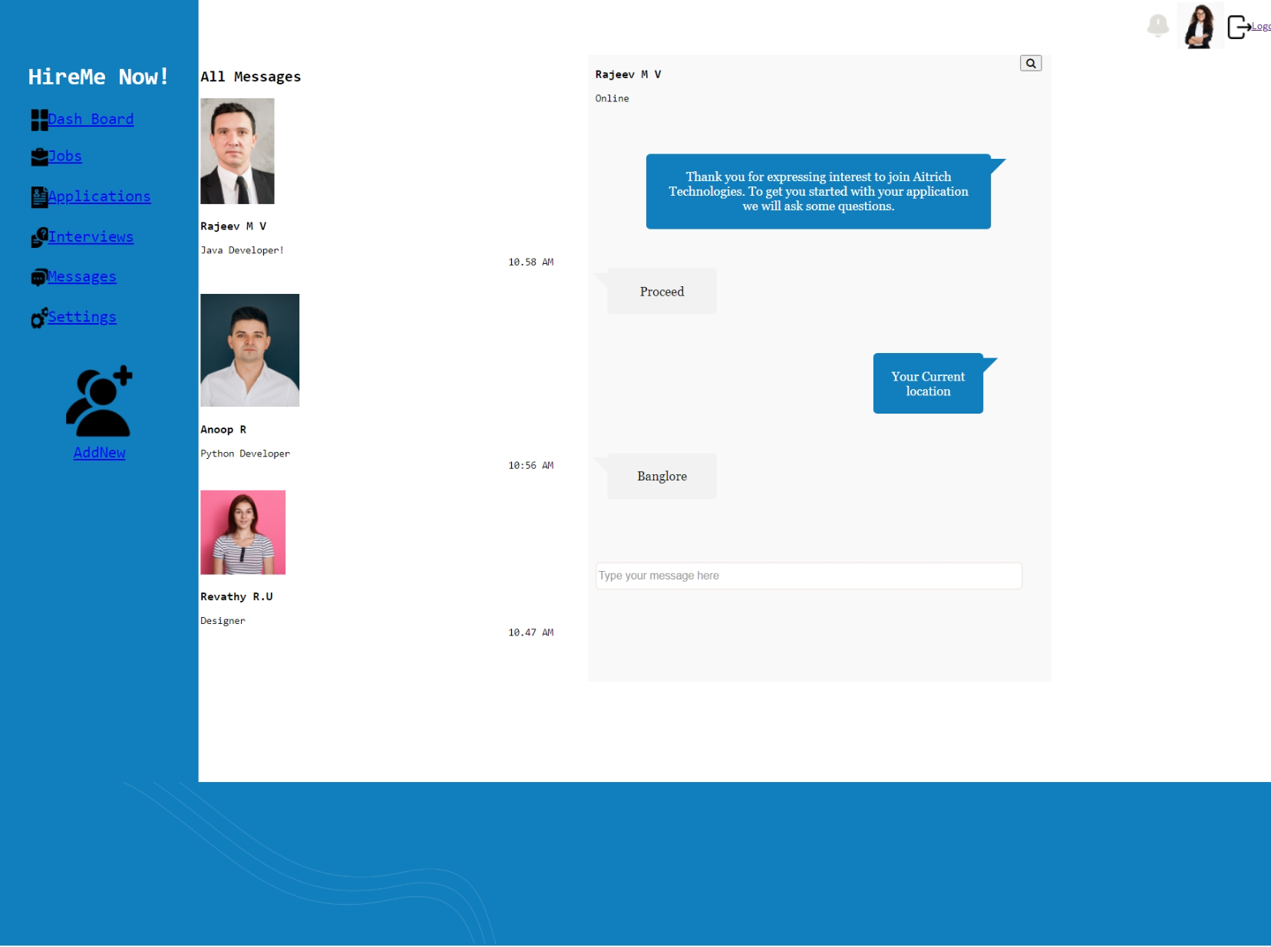

During this workshop, we will construct a webpage for the Job Portal System using HTML tags and style it using CSS. We will include both internal, inline, and external CSS to demonstrate how CSS is applied. In this workshop, our primary focus will be on selecting selectors and utilizing typography properties, font properties, and background properties in CSS. Additionally, students will be assigned additional tasks to add sidebar and footer to the template using HTML tags and CSS to achieve the expected output.